|  |  |
| --- | --- |
| **PHP** | **ASP.Net** |
| No threading | Supports threading |
| Cross platform | Cross platform |
| Larger community | Smaller community |
| Interpreted | Compiled |
| Deployment anywhere | Must be deployed on a microsoft server |

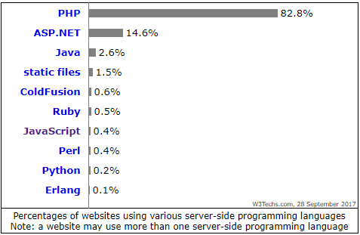

**Figure 1:** Percentage of websites using various server-side languages. 28 September 2017